

**The Essex Tai Chi Academy Newsletter Eleven, July 2019**

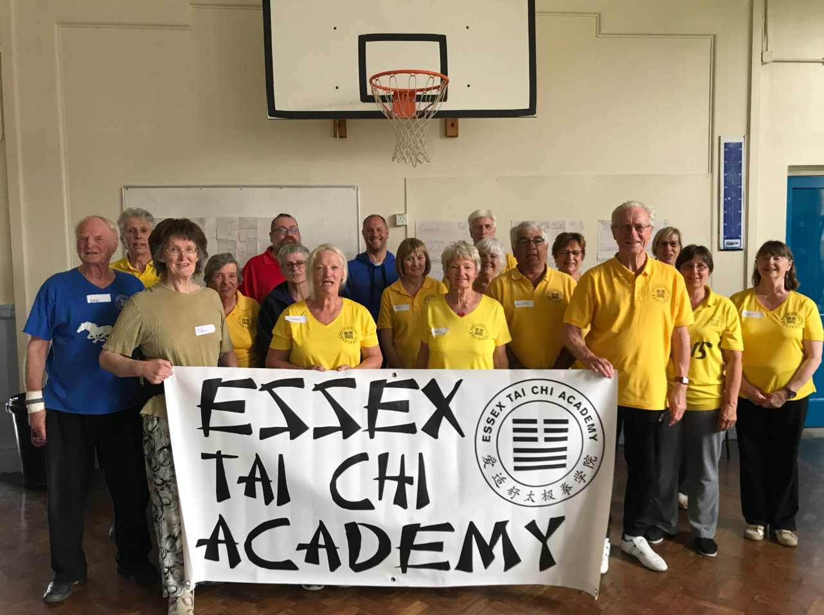

**Congratulations Judy and Lisa on a wonderful weekend.**

**You should feel proud, as we do, of such a successful event.**

**The Essex Tai Chi Academy runs classes in Tai Chi, Sabre, Lok Hup Ba Fa and Sword at Birchanger, Black Notley, Burnham-on-Crouch, Cold Norton, Felsted, Maldon and Mundon**

[www.essextaichiacademy.org](http://www.essextaichiacademy.org) [info@essextaichiacademy.org](mailto:info@essextaichiacademy.org)

**Workshop with James Elser**

Well, Judy and Lisa, you did it! Extraordinary hard work and persistence on your part, but a huge success. Know you’d like to thank all your helpers for signage, hospitality, registration, transport and catering assistance – as you said, ‘couldn’t have done it without them’. And of course Mal at the Plume and Julie from Le Café at St Peter’s Hospital for the lunches. The venue was good, the catering was spot on, and the weather improved on Sunday!

James’s generosity of spirit spread to everyone, uplifted us all, and everyone felt the benefit. He has 27 years’ experience and it showed, as he shared so much of his knowledge with us. As a student said, ‘James was really helpful – brilliant in the way he came across, and it was nice to get to talk to people from all over.’

The session on Friday afternoon was well attended with instructors from around the country. It featured the foundation exercises, Commencement (James’s favourite move) and Sweep lotus.

Afterwards some 28 of us enjoyed an excellent meal at the Queen’s Head on Maldon’s quay. James spent time exploring the boats and barges – in the pouring rain! He loved the town, the countryside, how green it all was, and the English layout.

Saturday’s session started well, and though James was a little unwell (and needed a ‘speaker’ for a while as he lost his voice) he was excellent in his approach and method. After lunch, sleeping/meditation left us all ready for the afternoon session. This included layers on the exercises, the first 17 moves twice, and Repulse monkey.

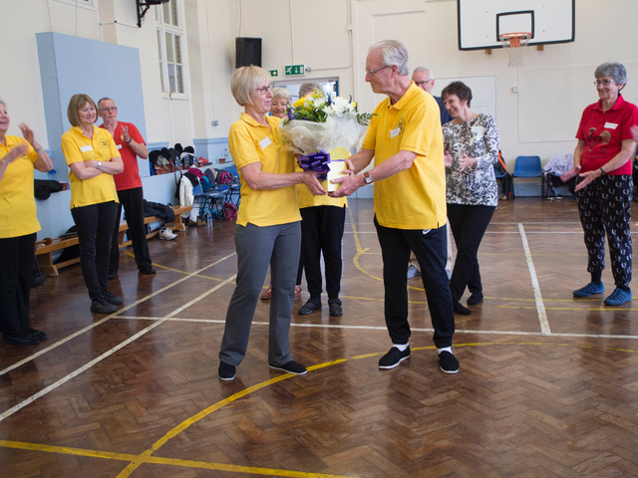

David presents ‘Samantha’ with flowers in recognition of her long-standing and huge input into the Essex Tai Chi Academy

Sunday began with exercises, and then we covered Cloud hands and Parting of wild horse’s mane. According to James, Mr Moy considered Repulse monkey, Cloud hands and Parting of wild horse’s mane the three most important elements of tai chi, seemingly because of the ‘foot head’ concept used throughout, these moves are where it comes into play most often.

Some of us finished the day at Wetherspoons, going over the weekend and expressing our thanks to James. He will be back for a sword & sabre workshop on 21st/22nd September and will be attending classes too.

**Liz Smith, Burnham-on-Crouch**

‘Where else but Burnham could we have such a lovely walk home?’  A friend spoke for all of us as we made our way up the town along the river Crouch.  The sun was shining, the tide was high, a couple of boats were under sail with many more at their moorings.  What a sight! So picturesque.

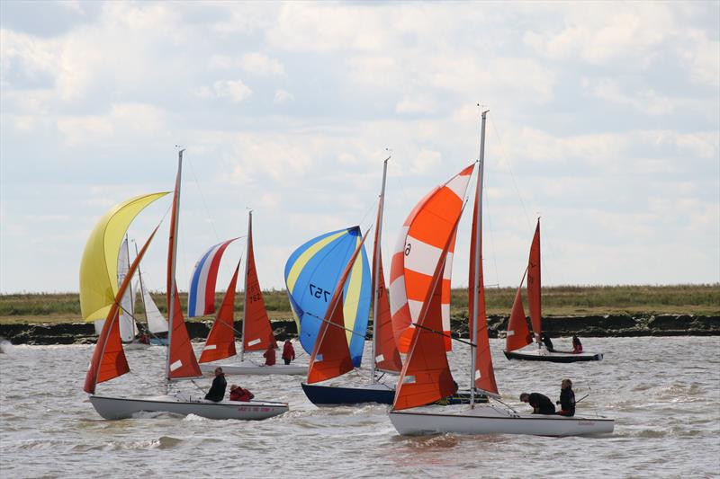

Burnham may be a bit ‘off the beaten track’ but has much to recommend it.  We are a mixed community of about 8,000. There are flourishing nursery, primary and secondary schools, a wide variety of churches, associations and clubs to join – no need to be lonely whatever your age – plenty of pubs and restaurants, a library, a cinema, a good bus service to Maldon and Chelmsford and a regular train service to London with rush hour journey time only an hour to Liverpool Street.

For a wealth of information about the town you could do no better than to have a look at the ‘official’ website designed in recent times by Burnham Town Councillors and a local website designer:  https//burnham.info

Tai Chi was recommended to me by a vestibular physiotherapist to try and improve my balance which takes a knock after attacks of a type of vertigo.  My husband, Keith and I joined the Essex Tai Chi Academy (Burnham branch) over a year ago. We love the classes although we are still not very good. Lisa is our excellent teacher.  Others in the group are much more skilled at tai chi but are always welcoming and seem not to mind our efforts. Keith, who is now in his 80s, amazed me by deciding to join, and his children are tickled pink about it!

[www.essextaichiacademy.org](http://www.essextaichiacademy.org) [info@essextaichiacademy.org](mailto:info@essextaichiacademy.org)

**An example of the depth of Mr Moy's knowledge – Toni Walsh**

By the time of this incident, I had been a class instructor within the Taoist Tai Chi Society, which was then under Mr Moy's leadership, for several years. I was attending an international worksh**o**p at the GB society's Jean Usher Centre in Colchester. It was usual for Mr Moy to sit at the front of the hall observing what we were doing while the workshop itself was being led by an instructor he’d brought with him from Canada. On the third day of the five-day workshop, we were doing lots of don-yus, when Mr Moy went over to one of our overseas visitors and took him to one side while indicating the rest of us should continue with our don- yus.

We all continued but I, and I suspect most of the others too, watched what followed from the corner of one eye. I saw Mr Moy massaging and manipulating parts of this gentleman's body**,** which included some quite forceful-looking actions. Finally, Mr Moy got him to stand in what we'd call the standing meditation position with the arms low, carefully adjusting the posture before returning his attention to the rest of us.

About 40 minutes of don-yus and tor-yus later, we were allowed to stop. Mr Moy went back to the man and invited him to walk around slowly for a while. He then took him to the front and we all sat down. At Mr Moy’s behest and with the man’s permission, the instructor, himself a doctor, explained to us that the gentlemen was suffering from an advanced case of AIDS and was very frail with wasted muscles and drawn, pale skin. This was back in the mid-1990s when AIDS was no longer taboo but there was no cure, so it was still usually a death sentence. It seems that he'd gone to Mr Moy at the start of the day and thanked him for the Tai Chi because that night (the second night of the workshop) had been the first good night's sleep he'd had in a long time. Mr Moy then did what he often did when he'd worked with somebody**,** and asked him to explain how he felt now **–** he had difficulty putting it into words but eventually conceded that he felt transformed and as if a breeze could blow through him. Mr Moy told him to continue practising his Tai Chi diligently.

A couple of years later, at another international workshop, I sat with a group of Tai Chi-ers at the lunch table, and joined **in** the conversation. It took me a while to reali**z**e that the sturdy chap in clearly good health whoI was sitting next to was the self-same man I'd seen before! Coincidence? Spontaneous remission? I don't know, but it impressed me.

[www.essextaichiacademy.org](http://www.essextaichiacademy.org) [info@essextaichiacademy.org](mailto:info@essextaichiacademy.org)

**Jacqueline Twyman**

As this is my last Newsletter as editor, please allow me some idiosyncratic thoughts that haven’t made it into previous editions:

Zoe Williams, *Guardian Weekend*, 20 April 2019

There is no point trying to measure, or prove, or find the mechanism for inner peace. If you find it, just quietly enjoy it.

Feruccio Busoni (1866–1924) was an Italian composer, pianist, and much else besides, who once said he prized the most those empty passages composers make up to get from one ‘good part’ to another. He said such workmanlike but minor transitions reveal more about a composer – the actual vernacular of his imagination – than the deliberately bravura moments. (Edmund White, *A Boy’s Own Story*, Picador, 1982)

It is in the transitions between the moves, rather than the moves themselves, that important work and progress happen. (See also * below.)

Think about how this impacts on your approach to tai chi – are the ‘big moves’ more important to you than the ‘linking moves’? If so, why do you think that is?

David Jays, on the tricks performers use to avoid forgetting ‘what comes next’

(*The Guardian*, 9 December 2017):

‘The brain and the body absorb information at different rates; muscle memory arrives quicker and lasts longer than language.’ And quoting Icelandic classical guitarist Petur Jonasson, ‘When you make a mistake, it’s always in the same place, between the chunks.’

Jays again: ‘The brain seems to stutter in these transitions... Memorizing something as an experience, rather than as pure information, seems to help.’

For instructors, from Paul Guscard, Harlequins’ head of rugby

As a coach you’re essentially a teacher as well as a salesman. Can I get people to buy in? Everyone’s got knowledge: it’s about how well you transmit that information.

My fortune cookie this Chinese New Year read – ‘You will always be surrounded by true friends.’ How lucky am I for that to be the case through the comradeship forged thanks to the Academy. Any of you visiting Maldon will always be welcome for a visit/lunch/afternoon tea. Just phone on 10621 850450. Thank you all...ow lucky am I

[www.essextaichiacademy.org](http://www.essextaichiacademy.org) [info@essextaichiacademy.org](mailto:info@essextaichiacademy.org)

**Reminders**

Definition of a workshop/practical seminar/joint class: a meeting at which a group of people engage in intensive discussion and activity on a particular subject or project. Accordingly, offered by other Tai Chi groups:

Saturday 10 & Sunday 11 August, tai chi with Doug Overholt & Susan Carson –

Cambridge Regional College. CB4 2QT.

Friday 16, Saturday 17 & Sunday 18 August lok hup with Doug Overholt & Susan Carson –

Rushbury Village Hall, Wall under Heywood. SY6 7DX

Saturday 13 October, lok hup at St Ives – Corn Exchange

Sunday 17 November tai chi and ECTCA AGM at St Ives – Corn Exchange

*For instructors:*

Friday 9 August, with Doug Overholt & Susan Carson – Fen Drayton Village Hall

Saturday 28 September, Little Thetford Village Hall

**Subs**

The third quarter’s £60 subscriptionsare due from Monday, 1 July.

**Stay active!**

According to the Alzheimer’s Research and Prevention Foundation,

being active can reduce your chances of getting dementia by up to 50 per cent.

It’s recommended that you do 150 minutes of exercise a week –

so 30 minutes, five days a week.

Tai chi, yoga, walking and swimming are all good options,

And it’s a good idea to do a mixture of cardio, strength balance and coordination exercises.

But, first and foremost, make sure whichever exercise you choose,

it’s something you enjoy or you’ll never make it a habit.

Health Awareness.co.uk, in an

Independent Supplement by MediaPlanet, May 2018

[www.essextaichiacademy.org](http://www.essextaichiacademy.org) [info@essextaichiacademy.org](mailto:info@essextaichiacademy.org)

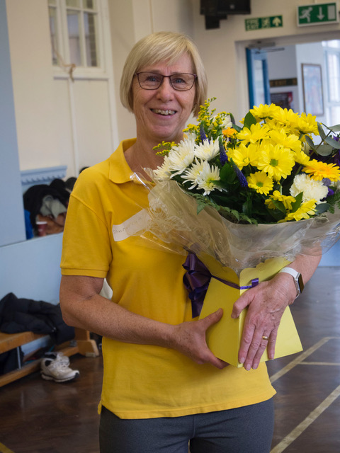

Thank you Mary. This is au revoir, not goodbye!